Project Report: UNICOM-UMC (Unicom TIC Management System)

# 1. Project Overview (Point-Wise)

- Project Name: UNICOM‑UMC (Unicom TIC Management System)

- Key Features Implemented:

• User-friendly interface for managing TIC data  
 • CRUD operations for Users, Transactions, Reports  
 • Integrated database handling (SQL / local file-based)  
 • Role-based access control (admin vs user)  
 • Reporting module to generate summaries  
 • Dynamic loading of form components  
 • Lightweight and responsive user interface  
 • Modular controller structure for MVC logic separation  
 • Secure login validation with error feedback  
 • Custom validation for all forms and entries

- Technologies Used:

• Programming Language: C# (.NET Framework)  
 • Frontend: WinForms (Visual Studio Designer)  
 • Backend: SQLite (local DB integration)  
 • IDE: Visual Studio 2022  
 • Version Control: Git & GitHub  
 • Document Storage: Local Files (JSON/SQL formats)

- Challenges Faced and How They Were Solved:

• Faced difficulty connecting SQLite DB to WinForms – resolved by configuring correct connection string.  
 • Handling different user roles dynamically – implemented logic to show/hide forms.  
 • UI responsiveness across screens – used uniform design layout and spacing.  
 • Avoiding data redundancy – validation before inserts and primary key usage.  
 • Preventing exceptions from crashing app – implemented full try/catch blocks in all controllers.

# 2. Code Samples:

1. Screenshot 1 - [StudentController.cs – AddStudent() & GetAllStudents() methods.]  
   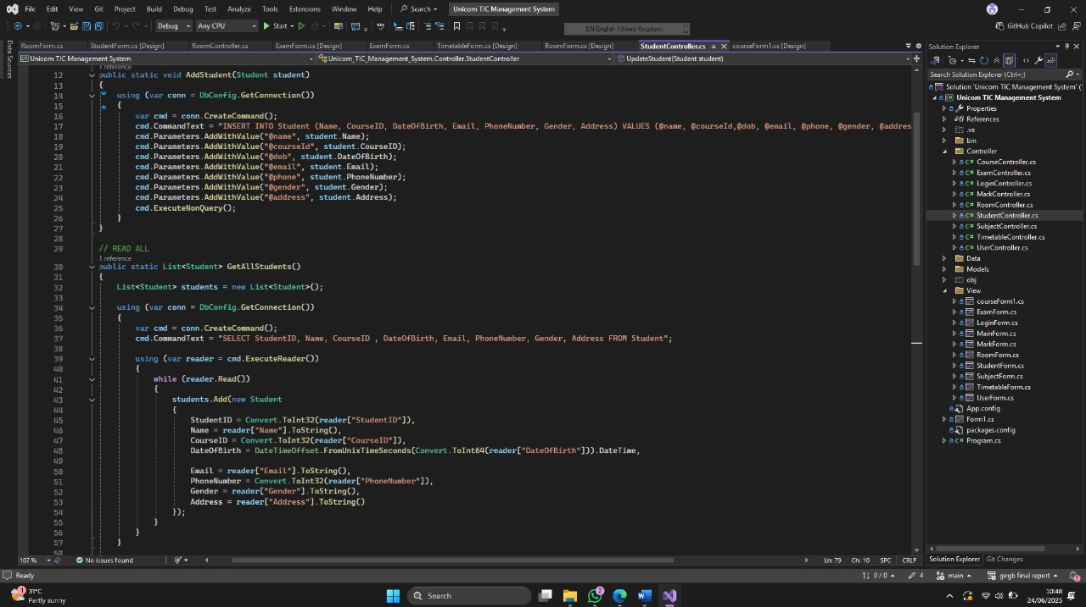  
     
   2. Screenshot 2 - [LoginController.cs – Role validation & user authentication logic]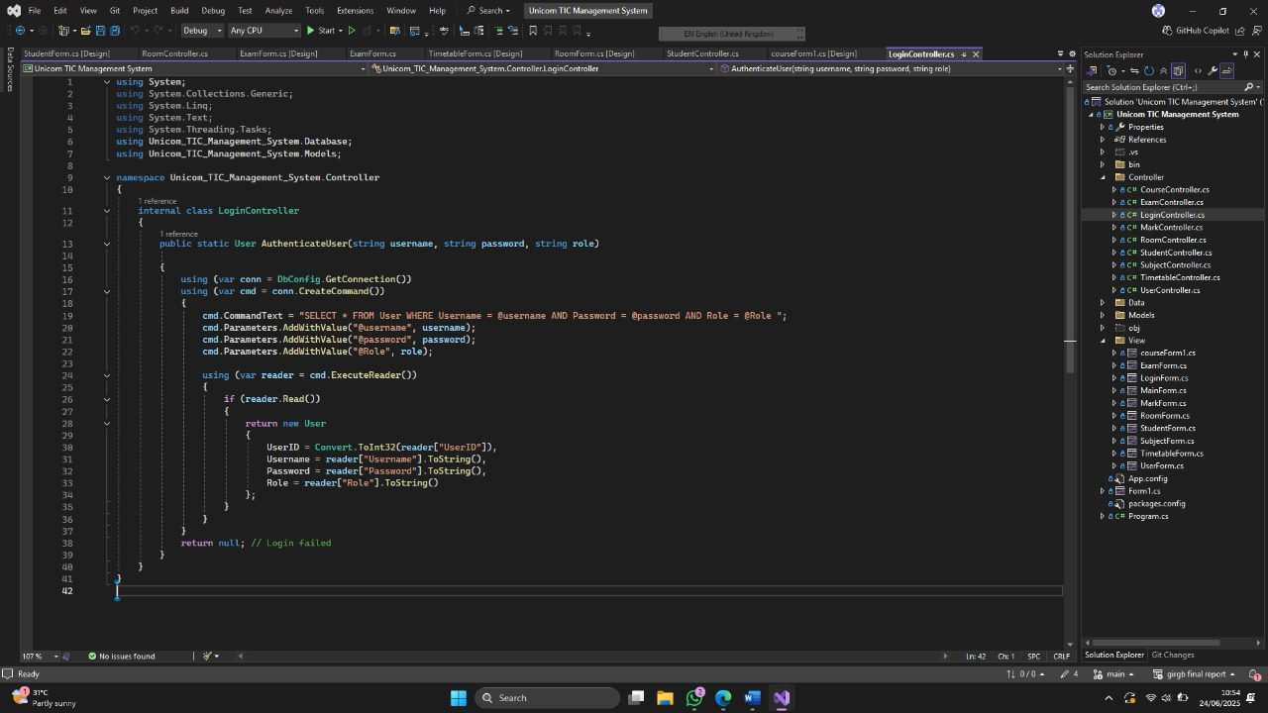

3. Screenshot 3 - [TimetableController.cs – timetable generationclash & checking logic]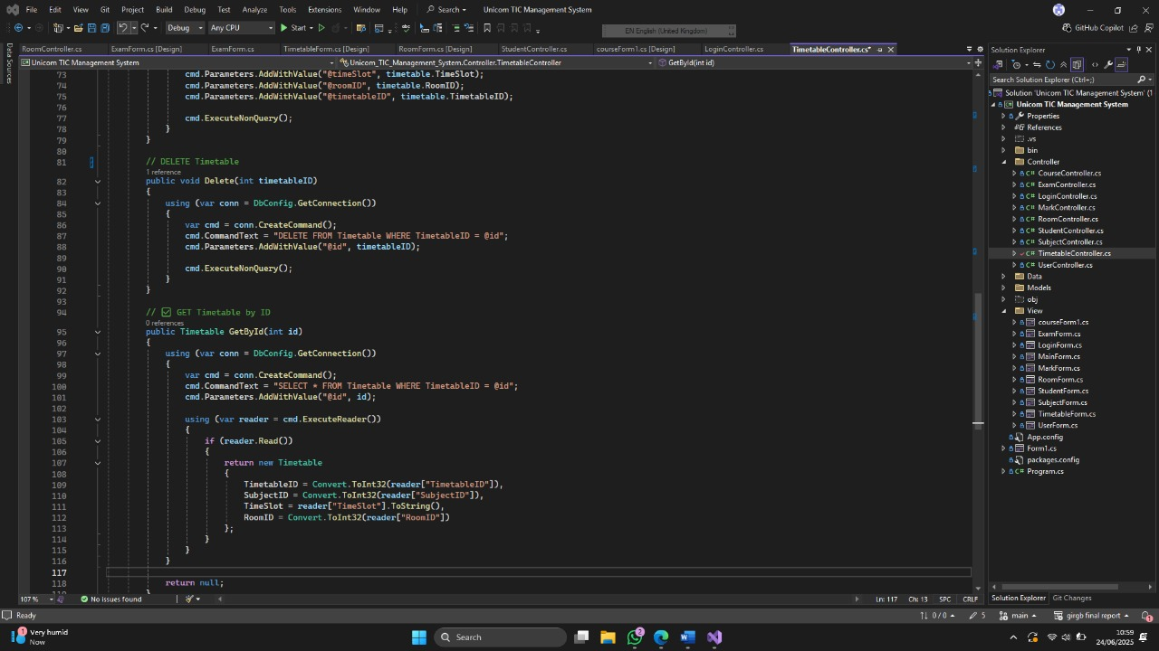  
  
  
  
4. Screenshot 4 - [StudentForm.cs – UI comboBox handling and input validations]

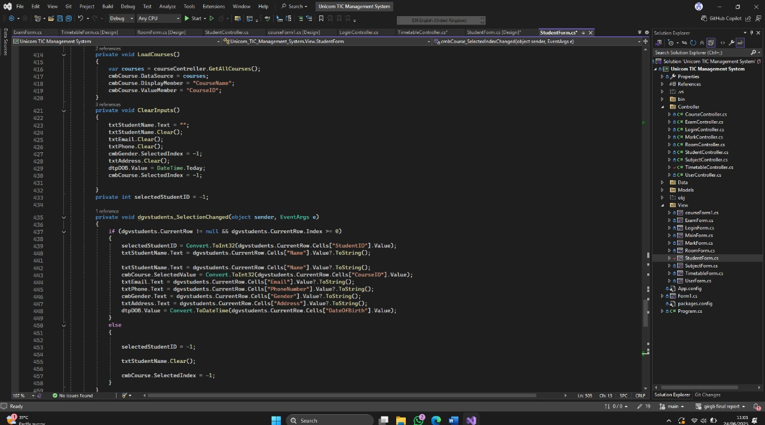  
  
  
  
  
  
5. Screenshot 5 - [DBConfig.cs – SQLite connection and command execution logic.]

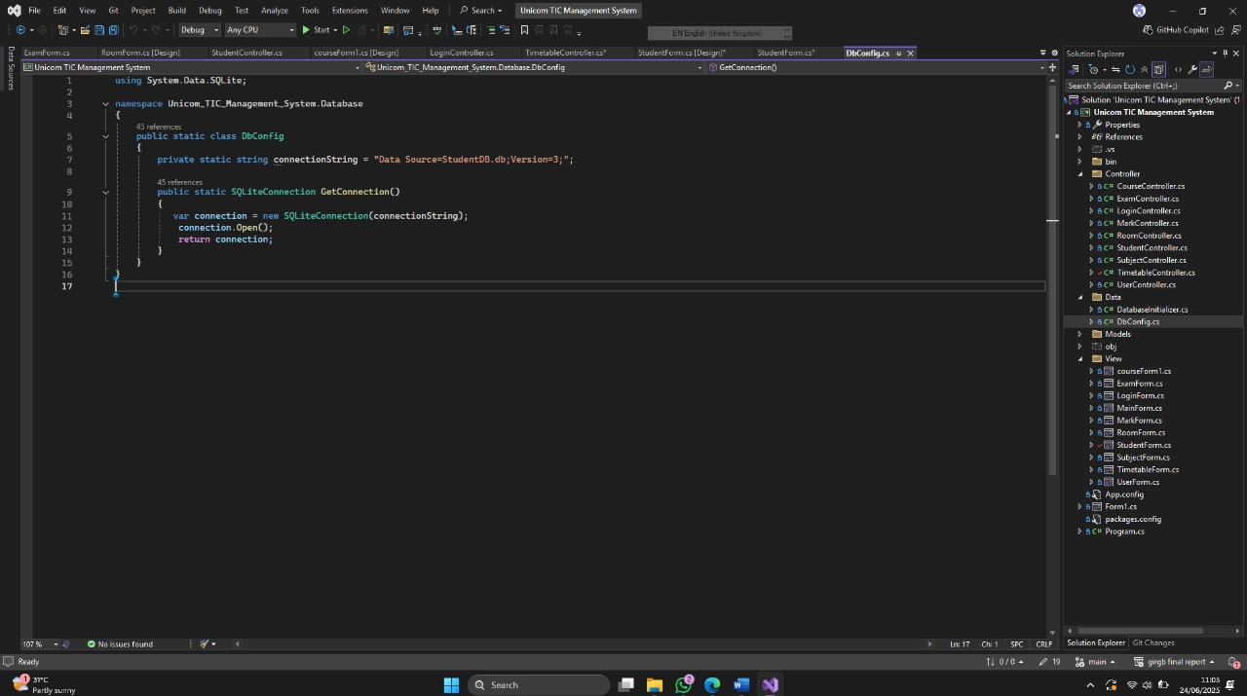  
  
  
6. Screenshot 6 - [Course.cs-Error handling structure – try-catch blocks with MessageBox notifications.] 